Part 1 — Hands-On Practice (Approx. 70 min)
A. Initialize and Configure (10 min)
- Create a folder named day1_day2_practice.
- Initialize Git and check for the .git folder.
- Configure username + email (locally).
git init
git config user.name "Your Name"
git config user.email "your@email.com"
git config --list –local
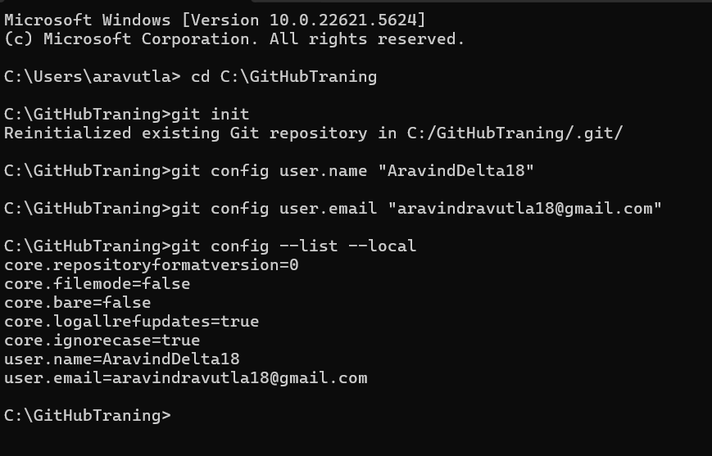
📝 Deliverable → Screenshot showing git init and git config output.
. File Lifecycle (25 min)
- Create three files:
intro.txt setup.txt notes.txt
- Add some text to each.
- Stage only intro.txt and setup.txt.
git add intro.txt setup.txt
git status
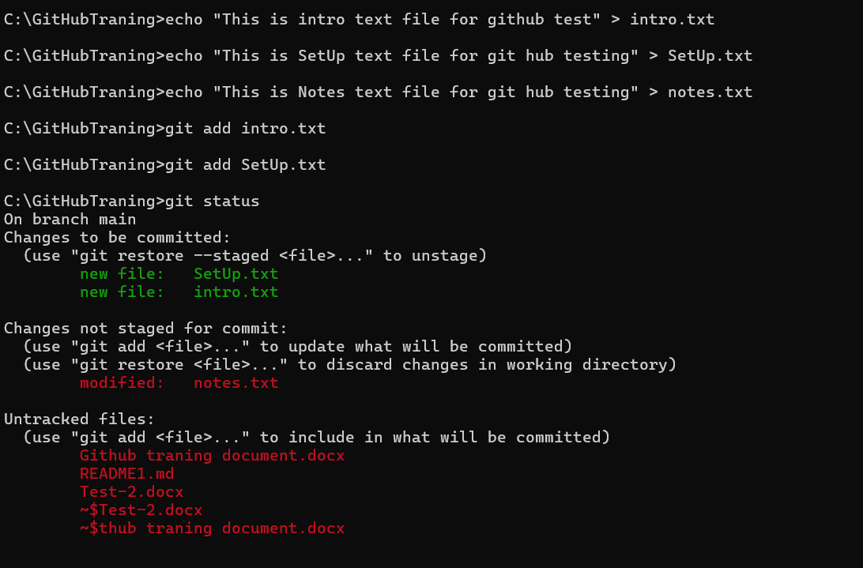
- Edit intro.txt again without re-adding.
- Compare results of:
git diff
git diff --staged
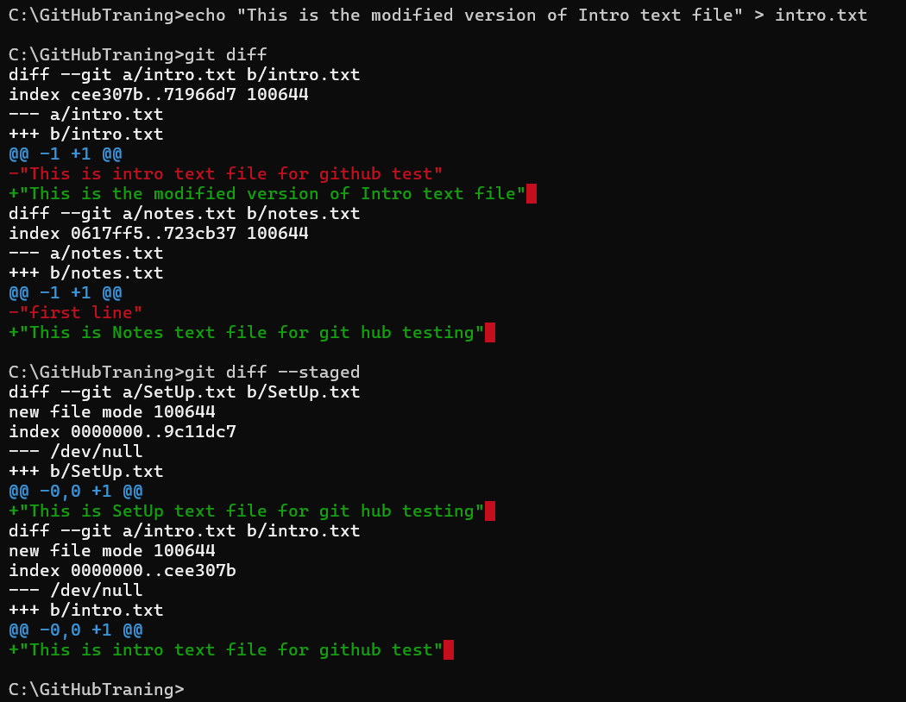
- Commit staged files:
git commit -m "First commit - intro and setup"
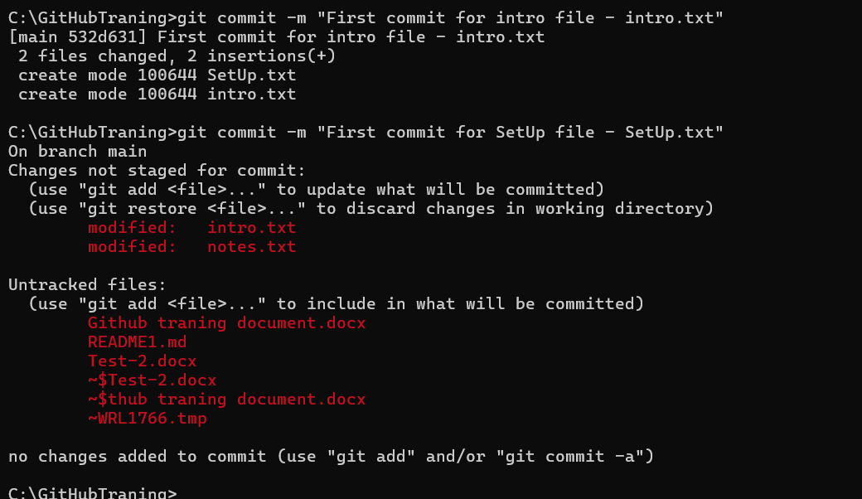
📝 Deliverable → In 2–3 sentences, explain why the second edit to intro.txt didn’t go into the commit.
Ans) The 2nd modification in intro.txt file is not committed because git only commits the staged files only. For first modification we staged the intro.txt file by using git add into.txt but when we modified again we couldn’t staged the file and instead of that we committed the files so because the first edit only committed in intro.txt file. The Git only commits the changes which are staged.
C. Inspect Internals (25 min)
Run these and note what each displays:
ls -a
git log --oneline
git show HEAD
git cat-file -p HEAD
git cat-file -p HEAD^{tree}
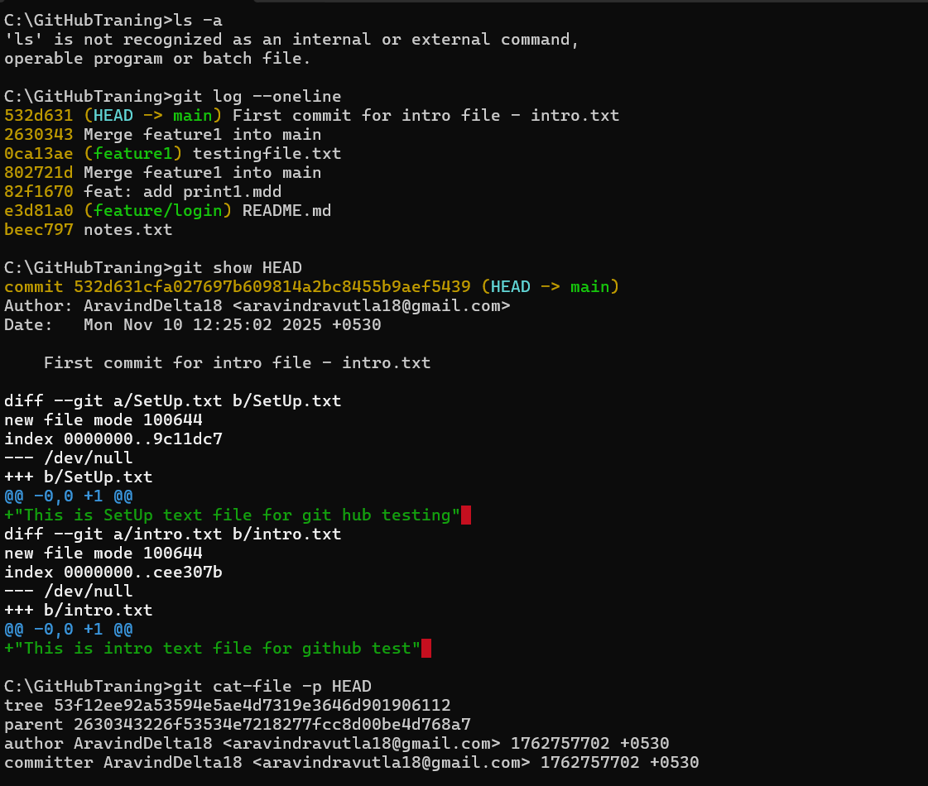
Then find one blob id and open it:
git hash-object intro.txt
git cat-file -p <that_hash>
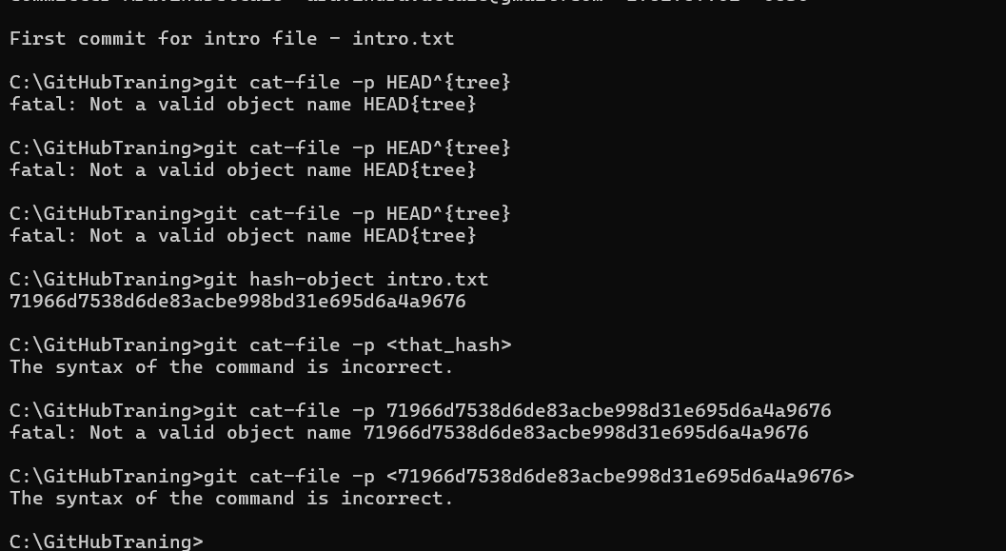
📝 Deliverable → Answer in 3–4 lines: what are blob, tree, and commit object?
And
Part 2 — Conceptual Quiz (Approx. 40 min)
Answer briefly (3–4 sentences each, simple English):
- What happens inside Git when you run git add file.txt?
when we run the git add file.txt, we are moving that to file to staging area. By running this command git understands that this file content is the Next commit.
And after running git add command and later you have edit that file then the 2nd or later modifications didn’t commit those changes until you move that file to staging area.
- Why do we say a commit is a snapshot, not a diff?
A commit in Git is called a snapshot because it saves the entire state of your project at that moment, not just the changes you made. Instead of storing only the differences (like some older version control systems), Git records the full content of all tracked files in that commit. This makes it easy to restore any version without applying a series of patches.
- What is stored inside the .git folder?
The .git folder is the hidden directory that Git creates when you run git init. It’s basically the brain of our Git repository. In simple terms, here’s what it stores
Head: it shows the current active branch info
config: it stores configurations details like user name and email and other settings
objects: it stores all project data including file contents.
Logs: it contains historical records of changes to references, including the commit history and branch movements.
refs: it stores the all branches and it's detailes and also stores the head etc..
index: Also known as the staging area, this file lists all the files prepared for the next commit.
- What does HEAD point to, and how is it updated?
HEAD in Git is a pointer to our current position in the repository. It usually points to the latest commit on the branch we have checked out. And When we make a commit or switch branches, HEAD is updated to point to the new commit or branch.
- What’s the difference between the Working Directory and the Staging Area?
The Working Directory is where we actually edit our files on our system, And it’s our real project folder. The Staging Area is like a waiting room where we put the changes we want to include in our next commit using git add file.txt. And the working directory holds all our changes, but only the ones we stage will go into the commit.
- What happens if you change a file after staging it?
If we want to change a file after staging it, Git will not include those new changes in the next commit. The commit only contains the version of the file that was staged when we run the git add. To include the latest changes, we must stage the file again before committing. Why doesn’t Git store whole files for every commit?
- What is version control, and how does Git make it easier?
Version control is a system that tracks changes of our files so we can go back to previous versions if needed. Git makes this easier by storing snapshots of our entire project or file, allowing us to branch, merge, and work without losing history. It also lets multiple people collaborate safely without overwriting each other’s work.
- What are tracked vs untracked files?
Tracked files means git already knows complete info about that like adding files, commits etc.. o Git keeps monitoring them for changes. Untracked files are new files in our working directory that Git doesn’t know about yet and won’t include in commits until we add them. For example, if we create a file using echo "first line" > intro.txt, it will be untracked until you run git add intro.txt.
- Write the complete flow of commands from creating a repo to committing your first file.
echo "first line" > print.txt
git add print.txt
git commit -m add "print.txt"
git log –oneline
git status

